**Lecture 2: Justin Martyr**

**Philosophy in the ancient world**

**Stoicism:** destructive emotions resulted from errors in judgment, and that a [sage](https://en.wikipedia.org/wiki/Sage_%28Sophos%29), or person of "moral and intellectual perfection", would not suffer such emotions. Stoics were concerned with the active relationship between cosmic [determinism](https://en.wikipedia.org/wiki/Determinism) and human [freedom](https://en.wikipedia.org/wiki/Freedom_of_will), and the belief that it is [virtuous](https://en.wikipedia.org/wiki/Virtue) to maintain a will (called [*prohairesis*](https://en.wikipedia.org/wiki/Prohairesis)) that is in accord with nature. Because of this, the Stoics presented their philosophy as a way of life, and they thought that the best indication of an individual's philosophy was not what a person said but how that person behaved.

Marcus Aurelius: "If you work at that which is before you, following right reason seriously, vigorously, calmly, without allowing anything else to distract you, but keeping your divine part pure, as if you were bound to give it back immediately; if you hold to this, expecting nothing, but satisfied to live now according to nature, speaking heroic truth in every word that you utter, you will live happy. And there is no man able to prevent this."

Seneca: "The point is, not how long you live, but how nobly you live."

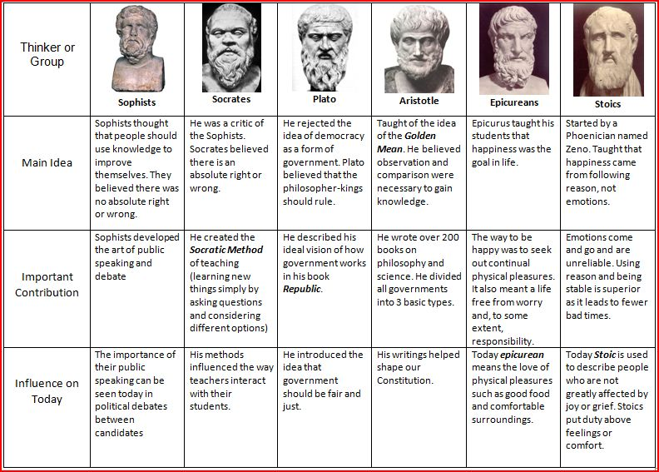**Platonism:**

**Ancient philosophers and their messianic context**

**Life of St Justin**

# Martyr Justin the Philosopher and those with him at Rome

Commemorated on [June 1](http://oca.org/saints/lives/2015/06/01)

[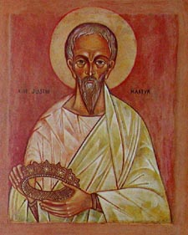](http://images.oca.org/icons/lg/june/0601justinmartyr.jpg)The Holy Martyr Justin the Philosopher was born around 114 at Sychem, an ancient city of Samaria. Justin’s parents were pagan Greeks. From his childhood the saint displayed intelligence, love for knowledge and a fervent devotion to the knowledge of Truth. When he came of age he studied the various schools of Greek philosophy: the Stoics, the Peripatetics, the Pythagoreans, the Platonists, and he concluded that none of these pagan teachings revealed the way to knowledge of the true God.

Once, when he was strolling in a solitary place beyond the city and pondering about where to seek the way to the knowledge of Truth, he met an old man. In the ensuing conversation he revealed to Justin the essential nature of the Christian teaching and advised him to seek the answers to all the questions of life in the books of Holy Scripture. “But before anything else,” said the holy Elder, “pray diligently to God, so that He might open to you the doors of Light. No one is able to comprehend Truth, unless he is granted understanding from God Himself, Who reveals it to each one who seeks Him in prayer and in love.”

In his thirtieth year, Justin accepted holy Baptism (between the years 133 and 137). From this time St Justin devoted his talents and vast philosophical knowledge to preaching the Gospel among the pagans. He began to journey throughout the Roman Empire, sowing the seeds of faith. “Whosoever is able to proclaim Truth and does not proclaim it will be condemned by God,” he wrote.

Justin opened a school of Christian philosophy. St Justin subsequently defended the truth of Christian teaching, persuasively confuting pagan sophistry (in a debate with the Cynic philosopher Crescentius) and heretical distortions of Christianity. He also spoke out against the teachings of the Gnostic Marcian.

In the year 155, when the emperor Antoninus Pius (138-161) started a persecution against Christians, St Justin personally gave him an Apology in defense of two Christians innocently condemned to execution, Ptolemy and Lucias. The name of the third remains unknown.

In the Apology he demonstrated the falseness of the slander against Christians accused unjustly for merely having the name of Christians. The Apology had such a favorable effect upon the emperor that he ceased the persecution. St Justin journeyed, by decision of the emperor, to Asia Minor where they were persecuting Christians with particular severity. He proclaimed the joyous message of the imperial edict throughout the surrounding cities and countryside.

The debate of St Justin with the Rabbi Trypho took place at Ephesus. The Orthodox philosopher demonstrated the truth of the Christian teaching of faith on the basis of the Old Testament prophetic writings. St Justin gave an account of this debate in his work Dialogue with Trypho the Jew.

A second Apology of Saint Justin was addressed to the Roman Senate. It was written in the year 161, soon after Marcus Aurelius (161-180) ascended the throne.

When he returned to Italy, St Justin, like the Apostles, preached the Gospel everywhere, converting many to the Christian Faith. When the saint arrived at Rome, the envious Crescentius, whom Justin always defeated in debate, brought many false accusations against him before the Roman court. St Justin was put under guard, subjected to torture and suffered martyrdom in 165. The relics of St Justin the Philosopher rest in Rome.

The holy martyrs Justin, Chariton, Euelpistus, Hierax, Peonus, Valerian, Justus and the martyr Charito suffered with St Justin the Philosopher in the year 166. They were brought to Rome and thrown into prison. The saints bravely confessed their faith in Christ before the court of the prefect Rusticus. Rusticus asked St Justin, whether he really thought that after undergoing tortures he would go to heaven and receive a reward from God. Saint Justin answered, “Not only do I think this, but I know and am fully assured of it.” The prefect proposed to all the Christian prisoners that they offer sacrifice to the pagan gods. When they refused he issued a sentence of death, and the saints were beheaded.

**Church Background - persecutions and the catacomb church**

The First Persecution, Under Nero, A.D. 67

The Second Persecution, Under Domitian, A.D. 81

The Third Persecution, Under Trajan, A.D. 108

The Fourth Persecution, Under Marcus Aurelius Antoninus, A.D. 162

The Fifth Persecution, Commencing with Severus, A.D. 192

The Sixth Persecution, Under Maximus, A.D. 235

The Seventh Persecution, Under Decius, A.D. 249

The Eighth Persecution, Under Valerian, A.D. 257

The Ninth Persecution Under Aurelian, A.D. 274

The Tenth Persecution, Under Diocletian, A.D. 303**[1]**

**His writings**

* Apology
* Dialog with Trypho: A principal question is whether the Christian belief in the deity of Christ can be reconciled with the uncompromising monotheism of the Scriptures. The dialogue is a valuable source of information about early Christian thought concerning Judaism and the relation between Israel and the Church as communities having a covenant relation with God. Toward the end of the dialog, Trypho asks, "Suppose that I were to become a Christian. Would I be required to give up keeping kosher and other parts of the Jewish law?" Justin replies: "Christians are not agreed on this. Some would say that you must give them up. Others, such as myself, would say that it would be quite all right for you, as a Jewish convert to Christianity, to keep kosher and otherwise observe the Law of Moses, provided that you did not try to compel other converts to do likewise, and provided that you clearly understand that keeping kosher will not save you. It is only Christ who saves you." They finally part friends, with Trypho saying, "You have given me food for thought. I must consider this further." An interesting feature is the dispute about texts. Justin would quote a passage from the Septuagint (LXX), the standard Greek translation of the Jewish Scriptures, and Trypho would reply, "That is not an accurate translation of the Hebrew. You Christians have been tampering with the text!" He never (at least as reportd by Justin) denies that Justin is correctly quoting the Greek manuscripts as they existed at the time, never brings forward an uncorrupted translation that has been preserved by Greek-speaking Jews.
* *On the Resurrection*
* *A Discourse to the Greeks*
* *Exhortation to the Greeks*
* *On Monarchy*
* *Exposition of the Faith*
* *Letter to Zenas and Serenus*
* *Answers to the Orthodox*
* *The Greek's Questions to the Christians*
* *Refutation of Certain Aristotelean Theses*
* *The Psalmist*
* *On the Soul*

**His influence**

Why is Justin Martyr important to us?

As one of the earliest Christian apologists, Justin is relevant to us because his context has huge resonance with the issues we face today in the decadent, pluralist West. He was facing a Greco-Roman culture convinced of pluralism but specifically antagonistic towards Christianity. He also had to contend with the huge difference between Christian morality and the morality of this pagan culture—an issue which he dealt with frequently. In this culture, sexual relationships in particular were relatively promiscuous and both homosexual and heterosexual relationships were completely acceptable and encouraged. Preaching the Christian gospel presented hearers with an inevitable moral challenge then, as it does today. Justin was preaching Christ and Christ alone in the ancient world where multiple philosophies and religions were competing for the attention of the public. Although a pluralistic state, some religions were frowned upon and explicitly outlawed, and Christianity was one of these. Christians’ refusal to worship the many gods of the age or to worship the emperor was perceived to be a threat to national security—like refusing a pledge of allegiance or an oath of loyalty to a king. As a result, Christians were under heavy pressure to acquiesce and make Christ just a part of the pantheon of gods on offer, rather than insisting on Him being the only true God. In his first Apology, Justin tried to demonstrate to those in authority that Christianity was not a threat to the state and should be treated as a legal religion. He wrote “on behalf of men of every nation who are unjustly hated and reviled.” Justin argued that Christians are, in fact, the emperor’s “best helpers and allies in securing good order, convinced as we are that no wicked man... can be hidden from God, and that everyone goes to eternal punishment or salvation in accordance with the character of his actions.”[2]

**What is an apologist?**

a field of **Christian** theology which present reasoned bases for the **Christian** faith, defending the faith against objections.

**Gnosticism:** a prominent heretical movement of the 2nd-century Christian Church, partly of pre-Christian origin. Gnostic doctrine taught that the world was created and ruled by a lesser divinity, the demiurge, and that Christ was an emissary of the remote supreme divine being, esoteric knowledge (gnosis) of whom enabled the redemption of the human spirit.

**Marcianism:** Marcion declared that Christianity was distinct from and in opposition to Judaism. He rejected entirely the Hebrew Bible and declared that the God of the Hebrew Bible was a lesser *demiurge*, who had created the earth, but was (*de facto*) the source of evil.

The premise of Marcionism is that many of the teachings of Christ are incompatible with the god of the Jewish religion. Focusing on the Pauline traditions of the Gospel, Marcion felt that all other concepts of the [Gospel](http://orthodoxwiki.org/Gospel), and especially any association with the Old Testament religion, were opposed to, and a backsliding from the truth. He further regarded the arguments of Paul regarding law and gospel, wrath and grace, works and faith, flesh and spirit, sin and righteousness, and death and life as the essence of religious truth.[3]

1. This list is from Foxe’s Book of Martyrs.
2. http://www.cslewisinstitute.org/webfm_send/618
3. http://orthodoxwiki.org/Marcionism