Holy Apostles Orthodox Church
347 Ridge Rd Lansing NY
HolyApostlesLansing.org
Fr James Worthington, Rector 315-706-6185
Rdr Bob West, Sr Warden SrWarden@HolyApostlesLansing.org

July 26, 2015
8th SUNDAY AFTER PENTECOST — Tone 7. The Repose of St. Jacob (Netsvetov), Enlightener of the Peoples of Alaska (1864). Hieromartyr Hermolaus and Martyrs Hermippus and Hermocrates at Nicomedia (ca. 305). Ven. Moses the Hungarian, of the Kiev Caves (Near Caves—ca. 1043). Martyr Parasceva of Rome (2nd c.). Ven. Gerontius of St. Anne Skete (Mt. Athos). The “EMVOLON” Icon of the Most-holy Theotokos in Constantinople.
Epistle: 1 Corinthians 1.10-18: For the message of the cross is foolishness to those who are perishing, but to us who are being saved it is the power of God.
Philippians 3.7-14 (Saint): I press on, that I may lay hold of that for which Christ Jesus has also laid hold of me.
Gospel: Matthew 14.14-22: The miracle of the feeding of the 5000.
Mark 10.29-31, 42-45 (Saint): The Son of Man did not come to be served, but to serve, and to give His life a ransom for many.

Coffee Hour Host: Olympia and Family. Next Week: Available.
Liturgy Time Change: For the months of June, July and August, the Divine Liturgy will begin at 9:30. The reading of the Hours will begin at 9:10. Please be punctual.
5th Anniversary: As we approach our 5th Anniversary, we need some help in organizing the appropriate festivities. Abp Michael will be with us on the exact date, and it would be good if we could welcome all of our local Orthodox brothers and sisters to a wonderful celebration.
T-Shirts: The t-shirts for the parish have arrived! They are a beautiful deep red emblazoned with a budded three bar cross, with the name of Holy Apostles Church on it. If you have ordered one, or would like to purchase one now, they are available in the back of the church.
OCF Leadership Conference: The Diocese and OCF are holding leadership conference in Trenton, NJ on September 12th. If you are interested, please see Fr James to make arrangements.
Online Sermons: Sermons and other videos promoting our parish have been posted on YouTube. Search for Holy Apostles Orthodox Video and subscribe to the channel. If you ever miss a Divine Liturgy or the Feast Days, you can catch with the sermon later in the week.
Welcome!: We warmly welcome all of our visitors! It’s good to have you with us! Please know that we are glad that you are here praying with us and invite you to join us after the service for a meal and to meet everyone in our community.
Diocesan Youth Day: Register for the Annual Diocesan Youth Day at Six Flags Great Adventure in Jackson NJ on August 20th from 9 AM to 8:00 PM. The cost of $30 includes all park fees, round-trip bus transportation from Saint Mary’s Church, and a meal voucher! Reservations must be made by August 10th. The event is for all diocesan youth and their friends, from elementary school to college for a day of fun and fellowship.
Mission Department: Fr Jonathan Ivanoff will be with us on August 1 and 2 to continue missionary training. Please clear your calendar for these days and be prepared to get excited for the growth of our mission parish.
LIVING:
Apr Timothy H
Apr Herman S
Apr John C
Apr Thomas E
Apr Michael T
Apr Stephen M
Pr Athanasios
Dn Symeon
Dn Michael
Abbess Silouana
Mother Raphaela
Mother Christophora
Mat Cecelia
Mat Katya
Mat Dorothy
Joshua
Brittany & Isaac
Gretchen
Peter
Marriane
Terrence
Helen
Judy
Gretchen
Mary & Susan
John & Carmine
Nathan
Leah
Helen
Lindsey
Susanne H
Elizabeth
Mary
Joe A
Daniel
Andrew & family
Harold
Wilhemina
Elizabeth
David
Madeline
Shirley
Larry
Christina
Jim & Kim
Rachel
Constantine & Maria
Gaetan
Jean
Christine
Samuel
Lisa
Iconographer Helena
Catechumens: Elliott
Children: Caleb, Christopher E, Anthony, Mia and Isabel,
BIRTHDAYS: None. ANNIVS: None.
NAMESDAYS: Olympia and Elijah.
REPOSED:
Priest Matthew
Priest John
Apr Alexander
Rdr Gregory
Daniel
Ada
Lillian
Joseph
Marie
Joseph
Laura
Martha
Stanley & Helen,
Taissia
Steluta
Theophan
Lynda
Florence
James
James R
Vasily
Modecai
NEWLY REPOSED: None. ANNIVERSARIES: None.

Schedule for This Week
Confessions are heard before and after Vespers and at any other convenient time.
Sunday, July 26: 9:10 Hours, 9:30 Divine Liturgy and Social Hour
Tuesday, July 28: 8:30 Morning Prayers
7 PM All-American Council Presentation
Wednesday, July 29: 8:30 Daily Matins
Thursday, July 30: 8:30 Morning Prayers
Friday, July 31: 8:30 Morning Prayers
6 PM Dinner with Fr Jonathan Ivanoff
Saturday, August 1: 6 PM Great Vespers
Sunday, August 2: 9:10 Hours, 9:30 Divine Liturgy and Social Hour,

August 8-9: 5th Anniversary Celebration

Prayer for Church Growth
Again, we pray to Thee, O Lord our God, that you would renew us and this parish by the Power of the Holy Spirit. Fill us with love and longing for Thee. Grant that we would seek not our own will but to do Thy will in all things and to be willing to lay down our lives out of love for Thee and for our neighbor. Draw thirsty souls to this place and remove their spiritual blindness, granting them through Thy grace to see the beauty of Thy Holy Glory in this place. Fill this community with new life, spiritual vigor and an insatiable desire to live godly and holy lives. Forgive us all of our sins as we fall down before Thee. Bring us all to a greater repentance and to an amendment of our lives as we look to Thee, the only Merciful and loving Lord Who calls all to salvation. We beg Thee, our merciful Lord, hear us, grant all of these petitions and all of our requests unto salvation: We pray Thee, hearken and have mercy.
Holy Apostles Orthodox Church
Lansing, New York

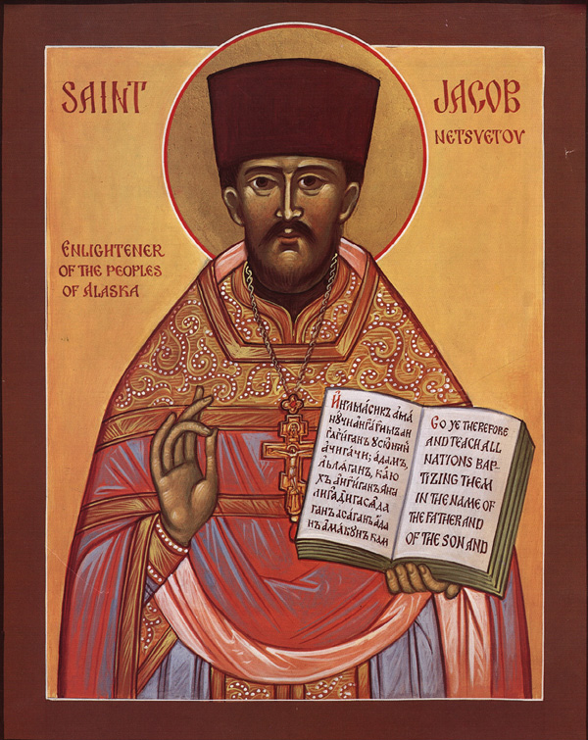

Sunday, July 26th, 2015
8th Sunday after Pentecost
Hymns for Sunday, July 26
Troparion Tone 7 (Resurrection)
By Your Cross You destroyed death.
To the thief You opened Paradise.
For the Myrrhbearers You changed weeping into joy.
And You commanded Your disciples, O Christ God,
to proclaim that You are risen,//
granting the world great mercy.
Troparion Tone 4 (St Jacob) (Alaskan melody)
O righteous Father Jacob,
adornment of Atka and the Yukon Delta;
you offered yourself as a living sacrifice
to bring light to a searching people.
Offspring of Russian America,
flower of brotherly unity,
healer of sickness
and terror of demons:
O Holy Father Jacob,//
pray to Christ God that our souls may be saved!
Kontakion Tone 7 (Resurrection)
The dominion of death can no longer hold mankind captive,
for Christ descended, shattering and destroying its powers.
Hell is bound, while the Prophets rejoice and cry:
“The Savior has come to those in faith;//
enter, you faithful, into the Resurrection!”
Kontakion Tone 3 (St Jacob)
O Holy Father Jacob,
teacher of the knowledge of God,
you revealed your love for your people,
taking up your cross and following Christ,
enduring hardships like the Apostle Paul.
Pray on our behalf to Christ our God//
to grant us great mercy!
Prokeimenon Tone 7
The Lord shall give strength to His people. The Lord shall bless His people with peace. (Ps 28/29:11)
v: Offer to the Lord, O you sons of God! Offer young rams to the Lord! (Ps 28/29:1)
Tone 7: The righteous shall rejoice in the Lord, and shall hope in Him. (Ps 63/64:11)
Alleluia Tone 7
Alleluia, Alleluia, Alleluia! v: It is good to give thanks to the Lord, to sing praises to Your Name, O Most High. (Ps 91/92:1)
v: To declare Your mercy in the morning, and Your truth by night. (Ps 91/92:2)
Tone 6: v. Blessed is the man who fears the Lord, who greatly delights in His commandments. (Ps 111/112:1)
Communion Hymns
Praise the Lord from the heavens, praise Him in the highest! (Ps 148:1)
The righteous shall be in everlasting remembrance. He shall not fear evil tidings. (Ps 111/112:6b-7a) Alleluia, Alleluia, Alleluia!

Travels of St Jacob Netsvetov
St. Jacob Netsvetov
Enlightener of the Native People of Alaska
In 1802, on an Aleutian Island in Alaska, Yeager and Maria Netsvetov became the parents of a son named Jacob. He was the oldest of four children. He had a sister Elena and two brothers Osip and Antony. During his young life, his parents moved to Siberia, Russia.
His parents were very poor, but worked hard to help their children. Rather than going to the Naval Academy like his brothers, Jacob wanted to learn more about the church, so he went to school at the Irkutsk Theological Seminary.
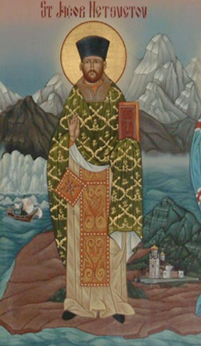
When he was twenty years old, he married a girl named Anna. He was then tonsured a sub-deacon. On March 4, 1828, he received the Sacrament of Ordination from Archbishop Michael, the same Archbishop that ordained St. Innocent.
After his ordination, Father Jacob wanted to return to Alaska and teach the people about God. So he began his long journey from Siberia to Alaska with his wife and father. After traveling by land and sea for 13 months and 14 days, he reached Alaska.
Father Jacob loved his parishioners so much that neither sickness nor weather would stop him from visiting. He spoke two languages, making it very easy for him to talk to the people he served.
Since there was no church building when he arrived, he held all of the services in a tent. Father Jacob would pack up his tent and take it with him on all of his missionary trips. He finally decided it was important to have a church, so he built the church of St. Nicholas. Once the church was completed, he constructed a school for the children. He taught the children to read and write in both Russian and Unagan Aleut, the native language of many people on the island. With the help of St. Innocent, he translated the Holy Scriptures and other important writings into the language of the Native Alaskans.
After his wife and father died, he wanted to be a monastic, but St. Innocent encouraged him to continue his missionary work. Through his work, he converted and baptized both the leader and all of the people in the village.
On July 26, 1864, he died in Sitka, Alaska. The glorification services for St. Jacob were held in Anchorage, Alaska on October 15-16, 1994.

AAC Delegates Express Solidarity, Support For Suffering in Middle East
ATLANTA, GA [OCA]: After the celebration of the Hierarchical Divine Liturgy early Thursday morning, July 23, 2015, and during the AAC’s fifth Plenary Session, delegates to the 18th All-American Council adopted a resolution expressing the Orthodox Church in America’s solidarity with Christians suffering persecution in the Middle East and calling on governments to do everything possible to ensure their safety.
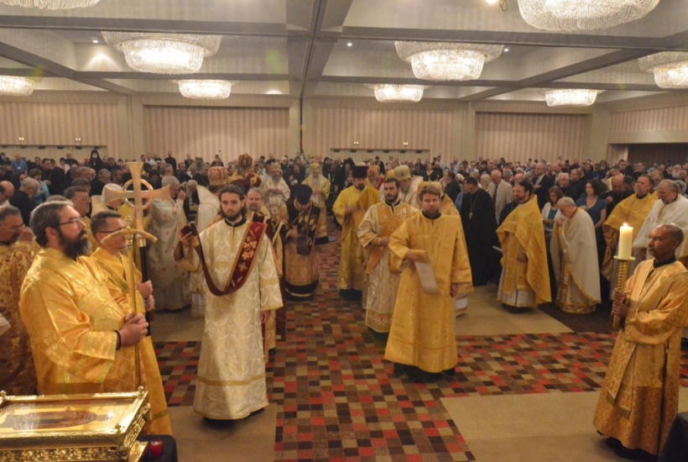
Presented by Dr. Paul Meyendorff and adopted by acclamation, the text of the resolution reads as follows.
“Whereas recent developments in the Middle East have caused great suffering to Christians in the area, leading to numerous deaths, desperate living conditions and mass movement of refugees, we, gathered at the 18th All-American Council in Atlanta, Georgia, express our solidarity and support for all suffering peoples in the area, especially our brothers and sisters in Christ, and we call on our respective governments to take vigorously all possible political and humanitarian measures to ensure their safety and the survival of Christianity in the lands where it first took hold.”
In a video produced by International Orthodox Christian Charities, introduced by Rada Tierney, the plight of the three million refugees and persons displaced from Syria and the measures being taken by the Patriarchate of Antioch and IOCC to alleviate their suffering were highlighted. In response to a recommendation by Archpriest John Zdinak, delegates spontaneously donated nearly $12,000.00 to assist IOCC in its ongoing ministry in the Middle East.

